


NON-DESTRUCTIVE TESTING SOCIETY (SINGAPORE)

This is to certify that
BETA TESTING SERVICES SDN BHD
has been elected as a
CORPORATE MEMBER
of the Non-Destructive Testing Society (Singapore) on
21th January 2021
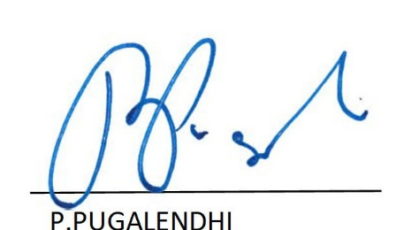
Given under our hand and Seal

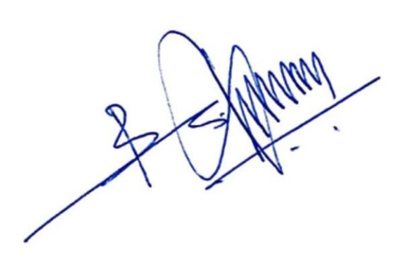

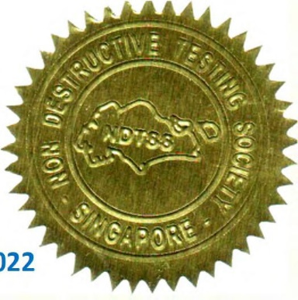

M.S.VETRISELVAN CHAIRMAN-MEMBERSHIP (NDTSS)

BABU SAJEESH KUMAR PRESIDENT
(NDTSS)

HONORARY SECRETARY (NDTSS)
P.PUGALENDHI

Membership No: 420904 Since: 21 January 2021 Expiry: 21 January 2024
022

